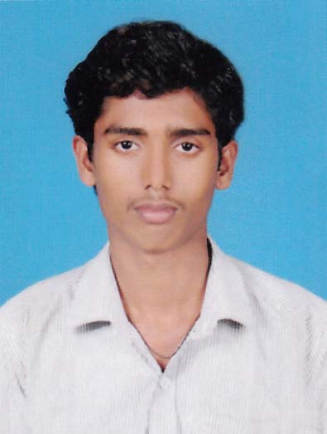
RESUME

SATHYASEELAN.K

Mob : +91 9961854529
S/o Kanakarajan.A
Ambattuchalla,
Kannimari P.O,
Palakkad – 678534.

OBJECTIVE

- Seeking a responsible position in an organization providing innovative and challenging opportunities in the field of technology and development.

ACADEMIC CHRONICLE

EXAM/ DEGREE | NAME OF INSTITUTE | UNIVERSITY/ BOARD | CGPA/ PERCENTAGE | YEAR OF PASSING
Diploma | Hindustan Poly Technic College Coimbatore | DOTE | 76% | 2016
Plus Two Automobile (VHSE) | S.V.V.H.S.S  Eruthenpathy | Vocational Higher Secondary Board Kerala | 73% | 2013
SSLC | PPHSS Kannimari | State Board Kerala | 68% | 2011

PROJECT

- Wind energy based mobile battery charger
TECHNICAL QUALIFICATION

- NDT level II
APPRENTICESHIP

- 1 year apprenticeship trainee in Titan Watches (Machine maintenance) at Hosur, Tamilnadu.
PERSONAL PROFILE

Father’s Name : Kanakarajan.A
Date of Birth : 28.05.1995
Languages Known : Read- English , Malayalam
Write- English, Malayalam.
Speak- English, Malayalam, Tamil
Nationality : Indian.
Religion & caste : Hindu
Marital status : Single.
PERSONAL SKILLS

- Capable to portray whatever is viewed.
- Ability to adapt with any environment.
- Strong and Flexible, able to work in Professional Environment.
DECLARATION

I here by declare that the above-mentioned details are true to the best of my knowledge and belief.

Date:
Place:
SATHYASEELAN.K

